
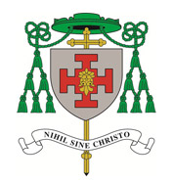
Parish Priest: Fr. Tony Grace
St. Gabriel’s
140 Lawton Road, Alsager
Stoke-on-Trent, ST7 2DE
Tel: 01270 877736
www.stgabrielsalsager.org.uk
St. Gabriel’s School & Playgroup, Tel: 875770 www.stgabriels.cheshire.sch.uk
St. Thomas More Catholic High School.
www.st thomasmore.cheshire.sch.uk

That
Parish Priest: Fr. Tony Grace
Permanent Deacon: Rev. Eddie Miller
Sunday 26th February 2017
Eighth Sunday In Ordinary Time

Parish Priest: Fr. Tony Grace
Permanent Deacon: Rev. Eddie Miller
Sunday 25th June 2017
12th Sunday of Ordinary Time

Permanent Deacon: Rev. Eddie Miller
Twenty Ninth Sunday in Ordinary Time
18th October 2026

Sunday 18 October – Today is World Mission Sunday
Today, parishes worldwide celebrate World Mission Sunday. By supporting Missio – the Pope’s charity for world mission – we stand united as God’s global family, in prayer, solidarity and action. The Holy Father has chosen the theme ‘One in Christ, united in mission’ to celebrate 100 years of World Mission Sunday and encourages us to unite with missionaries as they strive to reach out with God’s love to communities in need. Please pray for the work of mission and give what you can to this vital collection. To donate, use the Missio envelope, call 020 7821 9755 (office hours) or visit missio.org.uk to give a gift, set up a Direct Debit and Gift Aid your donation if possible.

SVP Bereavement Mass
The SVP will be holding the annual bereavement Mass on Saturday 7th November at 11am. A time to remember loved ones no longer with us. There is a sign up sheet in the porch if you would like family or friends to be remembered by the placing of a candle on the altar. If you are unable to personally place the candle, then a member of the SVP will do it on your behalf. If you need further information please speak to a member of the SVP or phone Michael Massey 07510 223337

Donation of Unwanted Gifts. Do you have any unwanted gifts hiding in cupboards or gathering dust on a shelf? Why not pass them our way and help boost our church funds. We’re collecting good-quality items that can be sold to support the life and work of our parish. It’s a cheerful win-win: you free up space, and your donation helps us keep our Parish thriving. Drop any items you may have in the church porch. Items will go on sale during October. Thank you for your wonderful generosity. Please contact Linda on 07875832699 for more information.

You will find our new DIGITAL COLLECTION PLATE, contactless terminal in the church.
Just use your contactless debit/credit card or smart phone/ device to make a donation. Here is your webpage link to support the Mission of the Church in St Gabriel’s, and through the Red Boxes, World Mission Sunday. https://donate.mydona.com/st-gabriel-alsager . Many thanks.

Missio/Red Boxes What is mission? What do missionaries actually do? What about the needs at home?
Watch our new film and hear from missionaries and our Church family around the
world to find the answers to these questions and more. https://missio.org.uk/wms/

Alsager Food Bank. Thank you for your continued support for the important work of the Alsager food bank. Please keep your donations coming in. Donations of long-life items are always welcome, e.g. Tinned vegetables, fruit, meat, fish etc. Your continued generosity is much appreciated. Thank you.
Christmas cards and Advent calendars. We have a selection of reasonably priced Christmas cards and Advent calendars available for sale at the back of church near the piety stand (for candles and cards) and the craft/gift stand. Please take time to visit this area as more seasonal items will be added over the next two months. Payment can be made by cash or through the card reader. All profits go to support our church. Thank you.

Cheshire, Shropshire and Welsh Borders Catholics
A group for practising Catholics aged between 25 - 44 to meet and cultivate friendships. Members are invited from Cheshire, Denbighshire, Flintshire, Shropshire, Powys and Wrexham to meet monthly for lunch in various locations. Contact cswbcatholics@proton.me

PLEASE PRAY FOR THE ETERNAL REST OF THE RECENTLY DECEASED, Maighread Tams, Kevin Smith, Jean Bennett, Maureen Ferris, & those whose anniversaries occur around this time: Mary Mulligan, Hilda McCann, Valerie Mason, Connor Young.
PLEASE PRAY FOR THE SICK: Especially for Michael & Margaret Massey, Fr. Michael Ryan, Norman Tams, Bobby O’Hare, Pat Clarke, Paul Forster, Nicole Horsefield, Deacon Peter Mascherenas, Leon Wood (5 years Sick), Valerie Condliffe, Agnes Mair, Lucía Capper, Kathleen Large, Sister Benedict, Michael Woolf, Barbara Fahy, George Lawton, Ben Thomas, Rita Jepson, Brigid Smith, Joanne Feeney, Brenda McDonagh, Margaret & Harold Barrow, Janet & Brian Woolf, Phil Ferris, Terry Flanagan, Regina Lo, Josephine Redmond, Dermot & Antoinette McGuire and all in our hospitals & nursing homes.

MASS TIMES WEEK COMMENCING 18th October 2026

Saturday 17th October  St.Ignatius of Antioch Sunday 18th October  29th Sunday in Ordinary  Day of Special Prayer for World Missions  Second Collection | 6.00 pm  6.30 pm Vigil Mass  11.00 am  11.30 am Mass | Adoration and Confession  Winnie, Patrick, Michael, Gerry & Mary Maughan & all Deceased of Maughan Family, Jean Bennett RIP, Rev Paul O’Grady RIP, Josephine Redmond (Sick)  Adoration and Confession  Kevin McKenna RIP, Elizabeth Dempsey RIP, Hilda McCann (Anniv), Dermot & Antoinette McGuire (Sick), Janet & Brian Woolf (sick)
Monday 19th October  St Peter of Alcantara | 7.00 pm  7.30pm Mass | Adoration and confession  Anthony Pitts-Tucker RIP, Inor David (Anniv), Trefor Campbell (Anniv), Maureen Hudson (B’Day Anniv), Bob Steele (Sick), Joe Shallow (sick), Andrew Hemmings (sick), Victoria Heaton (sick), Thanksgiving Intention for recovery of Keith Proudlove
Tuesday 20th October | 10.00 am  St. Anne’s Church  Nantwich Mass | For the Sick
Wednesday 21st October | 4.00 pm St Gabriel’s Church | Reception into Church of  Maighread Tams RIP
Thursday 22nd October  St John Paul II | 11.30 a.m Mass  St Gabriel’s Church  1.00 pm Funeral Service | Requiem Mass for  Maighread Tams RIP  The Birches Crematorium
Friday 23rd October  St. John of Capestrano | 9.30 am -10.00 am  10.00 a.m. Mass | Adoration & Confession  Cynthia Cartlidge (B’day Anniv), Anthony Pitts-Tucker RIP, Mary Mulligan (Anniv), Kevin Smith RIP, Bobby O’Hare (Sick) Maighread Tams RIP, Shrewsbury Secular Clergy
Saturday 24th October  Sunday 25th October  30th Sunday in Ordinary | 11.00 am  12.30 om  6.00 pm  6.30 pm Vigil Mass  11.00 am  11.30 am Mass | Baptism of Isadora Rene de Jesus  Baptism of Ocean Katherine Teresa Phillips  Adoration and Confession  Cynthia Cartlidge (B’day Anniv), Winifred Maughan (Anniv) & Family,  Norman Tams (Sick)  Adoration and Confession  Elizabeth Dempsey RIP, Hilda McCann (Anniv)
Please contact Fr Tony infostgabriels@yahoo.com for newsletter items
Many thanks for your continued generosity in the Parish Collection £484.89p
Prisoners Sunday Collection £234.80p
Diocese of Shrewsbury, Registered Charity Number 234025
Parish Safeguarding Officer, Paul Hassell 07795200353

Pope Leo XIV asks everyone to support World Mission Sunday
Tags: Pope Leo XIV · WMS2026 · WMS26 · World Mission Sunday 2026
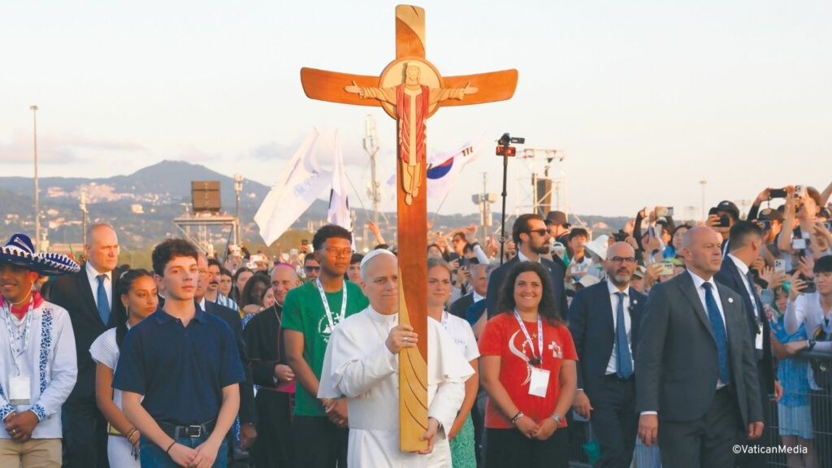
Pope Leo XIV has recorded a special video message for the celebration of World Mission Sunday on Sunday 18 October. Missio, the Holy Father’s charity for world mission and tasked with coordinating World Mission Sunday, is appealing for prayers and donations to support missionaries who serve communities in need, often in some of the poorest and most challenging places on earth.
This year’s theme, chosen by Pope Leo, is ‘One in Christ, united in mission.’ Being ‘one in Christ’ calls us to keep Our Lord at the centre of our lives and communities, and our mission is lived by witnessing to God’s love through our words and deeds.
In his message for World Mission Sunday, Pope Leo XIV shared:
‘Your prayers and practical support, particularly on World Mission Sunday, will be a great help in bringing the Gospel of God’s love to everyone, especially the poorest and those most in need. Every gift, no matter how small, becomes a meaningful act of missionary communion.’
This year’s celebration encourages every Catholic in the world to bring to life the mission given to them through baptism – to share the love of God with everyone, everywhere – by supporting missionaries who live alongside and serve communities in greatest need, wherever they are. Missionaries’ work is rooted in peace, dignity and hope, and offers help to everyone, regardless of their background or belief.
Donate to World Mission Sunday here>>

100 years of World Mission Sunday
Pope Pius XI established World Mission Sunday in 1926. It began as a simple appeal to support missionaries through prayer and giving. Today, one hundred years later, it continues to unite Catholics in a celebration of the Church’s missionary identity. In his video, Pope Leo shares his own personal connection to World Mission Sunday:
‘The realisation of Pope Pius XI’s aim has borne fruit in my own life. Looking back on my youth, I can see how the prayers offered to the Lord of the harvest mysteriously helped prepare my heart to hear Jesus’ call to follow him as an Augustinian missionary. Moreover, the prayers and contributions of the faithful encouraged and sustained my missionary work in Peru, as well as that of countless others throughout the world. For this reason, I would like to express my heartfelt gratitude to everyone who has supported World Mission Sunday over the years.’
World Mission Sunday is held every year on the penultimate Sunday of October. Every Catholic parish in the world celebrates Mass and contributes according to its means, so that churches in greatest need receive support from the worldwide Catholic family. The funds support missionaries and local churches serving communities that are new, young or poor, helping to provide pastoral care, education and healthcare. In 2025, Catholics in Myanmar raised £13,395, Malawi gave £31,310, and France donated £921,000. In England and Wales, £713,954 was generously raised.
Pope Leo says:
‘As we celebrate this centenary, I thank you for all that you will do to carry on the legacy of World Mission Sunday and to support generously the evangelising mission of the Church throughout the world.

How you can take part
Pope Leo XIV calls us to ‘go’ urgently and courageously into the future and thanks you for everything you will do to help missionaries throughout the world:
‘Your prayers and practical support, particularly on World Mission Sunday, will be a great help in bringing the Gospel of God’s love to everyone, especially the poorest and those most in need.’
Here are three easy ways you can get involved this World Mission Sunday:
- Pray for missionaries and the people they serve – Pray the Pope’s Official Prayer here>>
- Give to the World Mission Sunday collection in your parish, or donate directly to Missio>>
- Invite others to celebrate belonging to the universal Church, in person or online. Visit our official World Mission Sunday page here>>
Fr Anthony Chantry, Missio’s National Director in England and Wales says:
‘Pope Leo XIV’s message urges us to celebrate our unity in Christ, who sends us out with a common task: proclaiming, living and sharing God’s faithful love, “so that the world may believe in Christ the Lord” .
‘There are still multitudes of people in our world who do not know Jesus Christ and have no notion of the new life he offers them. Looking back is helpful, however the past is a place of reference, not a place of residence. We must look to the future to see how we can help others to share God’s love; especially with those who are in great need.’

Banner image: ©VaticanMedia

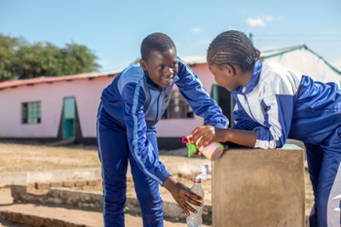

1
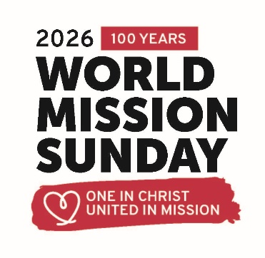



Joining the Catholic Church?
We will be offering an opportunity to come and find out more about the Rite of Christian Initiation of Adults (RCIA), whereby adults can decide if they want to join the Catholic Church at Easter. If you, or someone you know, would like t0 find out more about being a Catholic, please contact Fr Tony or Deacon Eddie.

Key messages
What is World Mission Sunday?
Since Pope Pius XI established World Mission Sunday (WMS) in 1926, it has grown from a simple appeal to support missionaries through prayer and giving, into a global celebration of the Church’s missionary identity. This year we celebrate 100 years of World Mission Sunday!
Today, it unites Catholics in prayer, solidarity and support for young and growing churches, reminding every baptised person of their call to share Christ’s mission.
Why does the Pope ask us to celebrate World Mission Sunday?
World Mission Sunday reminds us that we are one global family in Christ. Through prayer and generosity, all Catholics are encouraged to help share God’s love and to support the Church where it is young or facing great challenges.
Why do all parishes take part?
Mission is the responsibility of the whole Church and this global celebration of WMS is a reminder that we are one family in Christ. This special day is our chance to show love and solidarity to our brothers and sisters overseas. In offering our prayers, we unite with missionaries everywhere in communion and compassion to support them in spreading the Good News, and by giving a donation we respond to Christ’s call to share our faith in Jesus so that all may experience God’s love.
The Pope asks Missio, his charity for world mission, to coordinate World Mission Sunday (WMS) every year so that support can reach missionaries and communities living in great poverty, conflict and turmoil.
Missio exists to help all Catholics take part in Christ’s mission. So, on WMS, every parish contributes according to its means, so that churches in greatest need receive support from the worldwide Catholic family. For example, in 2025 Catholics in Myanmar raised £13,395; Malawi gave £31,310; Ecuador contributed £312,896; France donated £921,000; and here in England and Wales, we raised £713,954.
How has mission changed over the last 100 years?
The Church’s mission remains the same: to proclaim Christ and to serve humanity. Today, we understand that mission is the responsibility of every baptised person and is carried out through dialogue, justice, peace, care for creation, respect for cultures and witness to the Gospel.
Mission is an invitation to experience God’s goodness. We discover God’s unconditional, compassionate, life-giving love by encountering, getting to know and loving Jesus. A love in truth that sets us free.
The Church exists to help us carry out the mission we have all received from the Lord to bear witness to his words in our everyday lives. We are called to reach out to the lost, the oppressed and discouraged, and to tenderly care for those who suffer. Through the Church, we support and encourage each other to set out over and over again; never losing heart in the face of difficulties and obstacles.
What did Pope Francis teach about mission?
• Every baptised Christian is a missionary disciple
• The Church must go out to those on the margins
• Mission is lived through joy, mercy, encounter and accompaniment
What does Pope Leo XIV say about mission?
• The Church exists to share Christ with the world
• Mission grows through unity with Christ and one another
• Christians are called to bring hope – with courage, joy and openness
How does World Mission Sunday help?
Prayers and donations support local churches in providing such things as pastoral care, education and healthcare.
Donations to WMS go directly to missionaries and local churches in mission dioceses. Funds are distributed via local bishops in order to meet the priorities identified by the community, to support the community.
These communities request the support they need to share their faith and to bring lasting change – whether it’s help to build a simple chapel, provide vital healthcare, set up a school or create a safe space for children. Your support encourages communities to grow in faith, dignity and self-reliance.
What is Missio’s role?
Missio coordinates World Mission Sunday on behalf of the Pope. We help Catholics participate in the Church’s worldwide mission and ensure support reaches those communities that are most in need.
What does it mean to support the Church’s mission today?
It means enabling missionaries and local communities to share their faith by helping people encounter Christ through their words and actions, and by providing opportunities for the Spirit of God's infinite love to transform lives.
What is this year’s theme?
One in Christ, united in mission. A united, reconciled Church offers a credible and powerful witness to the Gospel and invites everyone to know Christ. The theme reminds us that mission is lived by witnessing to God’s love.
Everyone deserves to know that they are loved by God and that they are part of God’s human family.
Why has the Pope chosen the theme ‘One in Christ, united in mission’?
The mission of every disciple, and of the Church as a whole, is to continue Christ’s mission in the Holy Spirit: a mission ‘born of love, lived in love and leading others to love’ (Pope Leo XIV).
To be ‘one in Christ’ means keeping our gaze fixed on the Lord, so that he remains at the centre of our lives and communities – at the centre of our words, our actions and our relationships with one another.
We are united in Christ so that we can share in his mission. Jesus makes this clear when he prays for his disciples: ‘That they may all be one… so that the world may believe that you have sent me’ (John 17:21).
When we live as a reconciled, loving and united community, our lives become a powerful witness to the Gospel. Our unity gives credibility to our proclamation and invites others to encounter Christ. The more deeply we are united in him, the better able we are to work together in carrying out the mission he entrusts to us.
The global Missio network, the Pontifical Mission Societies, has a unique role in making this unity visible. As a worldwide network of prayer, solidarity and support, Missio is a living sign of the Church’s missionary communion, uniting Catholics together in prayer and support of the Church’s mission.
How can I take part?
• Pray for missionaries and the people they serve and empower
• Give what you can to the World Mission Sunday collection in your parish or donate directly to Missio: missio.org.uk/donate
• Invite others to celebrate our belonging to the universal Church by sharing our appeal in person or online, or both!
World Mission Sunday is a special day of prayer, solidarity and giving that unites Catholics in sharing the Good News of God’s love for all people.

  - 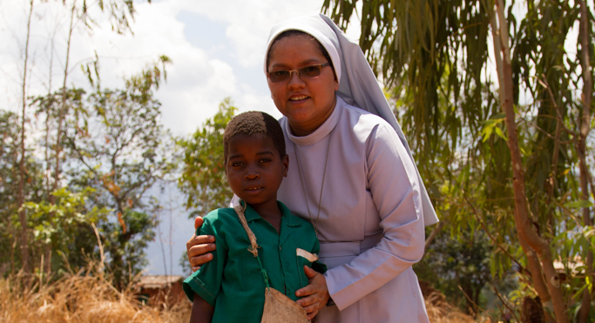

  - 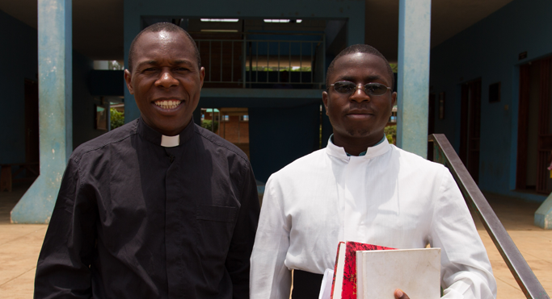

  - 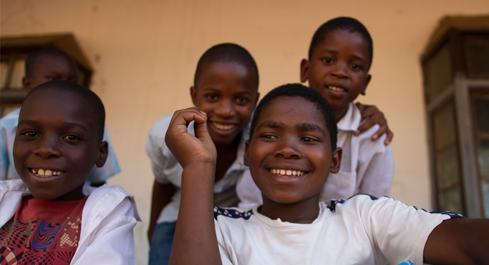

  - 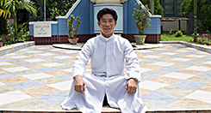

- Schools

- Contact

- Donate now
World Mission Sunday
- >
- World Mission Sunday

Feel free to use the resources below to promote and celebrate World Mission Sunday.
Pope Leo XIV
- The Holy Father’s Message for WMS 2026
Prayers for World Mission Sunday
- World Mission Sunday Official Prayer (PDF) (Word doc)
- World Mission Sunday Official Prayer Card
- World Mission Sunday Official Prayers of the Faithful (Intercessions) (PDF) (Word doc)
- Holy Hour: Mission Rosary focus (PDF) (Word doc)
- Holy Hour: World Mission Sunday focus (PDF) (Word doc)
Resources for your parish
- Counting the World Mission Sunday collection
- Inserts for your parish newsletter (PDF) (Word doc)
- Parish Leaflet Guide to WMS26
- QR code Donate link for your newsletter
- Short Talk for World Mission Sunday (PDF) (Word doc)
- Practical FAQs (PDF) (Word doc)
- Holy Hour: Mission Rosary focus (PDF) (Word doc)
- Holy Hour: World Mission Sunday focus (PDF) (Word doc)
Posters to download and print
- A4 Poster 1 (PDF)
- A4 Poster 2 (PDF)
- QR code Donate link for your newsletter
Key messages and short talk
- Short Talk for World Mission Sunday (PDF) (Word doc)
- Key messages (PDF) (Word doc)
Resources for children
- Activity for KS1
- Activity for KS2
Missio
Proud to be the Pope’s charity for world mission
Missio ignites God’s love by helping local missionaries to work alongside global communities that are poor or in need, regardless of their background or belief. more...
Follow Us
- Twitter
- Facebook
- Instagram
- YouTube
Recent Posts
- Pope’s Prayer Intention – October 2026
- Mission Rosary: Artisans of Peace
- Faith, generosity and the Red Box
- Five Venerable Fulton Sheen Minute Missions
- WMS26: ‘Let children, let everybody come to God.’
Contact Info
- Address:23 Eccleston Square, London, SW1V 1NU
- Phone:020 7821 9755Opens in your application
- Email:info@missio.org.ukOpens in your application
Registered in England and Wales Charity No. 1056651


- Home
- About Missio
- Donate
- Privacy Notice
- Missio Safeguarding Policy
- Contact Missio

Copyright 2026 - Missio | Web site managed by Rare Earth Digital

Holy Hour Resources and suggestions based on the Holy Father’s Message
‘One in Christ, united in mission’ Pope Leo XIV
The theme chosen by Pope Leo XIV for World Mission Sunday 2026 is ‘One in Christ, united in mission’. In his message for World Mission Sunday, Pope Leo stresses the need for us to ‘keep our gaze fixed on the Lord’.
Spending time in adoration of the Blessed Sacrament is a concrete way in which we can unite ourselves before the Lord; to pray, be inspired and encouraged in the mission we share with our sisters and brothers around the world.
‘…being “one in Christ” calls us to keep our gaze fixed on the Lord, so that he may truly be at the centre of our lives and communities, the centre of every word, action and interpersonal relationship, leading us to say with amazement: “It is no longer I who live, but it is Christ who lives in me” (Galatians 2:20).’ - Pope Leo XIV, Message for the 100th World Mission Day 2026
[You may wish to read the text above as an introduction before the Blessed Sacrament is exposed]
Exposition
[As the Blessed Sacrament is processed from the place of reservation, a song may be sung]
Possibilities include:
- Be still for the presence of the Lord
- Taizé: Bless the Lord my soul; Jesus Christ, Bread of Life; Laudate omnes gentes; O Christe Domine Jesu; Ubi caritas
- There at the Table (One Hope Project)
Adoration
It is important to enable periods of silence during the time of adoration. Readings and prayers can be interspersed during the time of adoration.
Pope Leo XIV’s message for World Mission Sunday this year is split into three themes (One in Christ; united in mission; mission to love). You may wish to use one of the three themes as a structure for the time of reflection. Alternatively, you may wish to hold three

Holy Hours, one based on each theme. Below you will find extracts from the message under each heading which can be read out, perhaps interspersed by silence and music.
The main Scripture that Pope Leo reflects upon is John 17. You may wish to start with a reading from that chapter. The full text is below, along with a suggested section which can be read aloud.
Scripture Reading: John 17:17-23 English Standard Version
Jesus said: “Sanctify them in the truth; your word is truth. As you sent me into the world, so I have sent them into the world. And for their sake I consecrate myself, that they also may be sanctified in truth.
“I do not ask for these only, but also for those who will believe in me through their word, that they may all be one, just as you, Father, are in me, and I in you, that they also may be in us, so that the world may believe that you have sent me. The glory that you have given me I have given to them, that they may be one even as we are one, I in them and you in me, that they may become perfectly one, so that the world may know that you sent me and loved them even as you loved me.”
Reflections
From Pope Leo XIV’s Message for the 100th World Mission Sunday 2026
Theme 1: One in Christ – Missionary disciples united in him and with our brothers and sisters
…The mystery of union with Christ lies at the heart of mission. Before his Passion, Jesus prayed to the Father, ‘that they may all be one. As you, Father, are in me and I am in you, may they also be in us’ (John 17:21). These words reveal Jesus’ deepest desire, as well as the identity of the Church as a community of his disciples…
…Being a Christian is not primarily about practices or ideas; it is a life in union with Christ, in which we share in his filial relationship with the Father in the Holy Spirit...
…the Church’s primary missionary responsibility is to renew and sustain spiritual and fraternal unity among its members. In many situations, we encounter conflicts, polarisation, misunderstandings and a lack of mutual trust. When this occurs even within our communities, it undermines our witness. The evangelising mission that Christ

entrusted to his disciples requires, above all, hearts that are reconciled and eager for communion...
…being ‘one in Christ’ calls us to keep our gaze fixed on the Lord, so that he may truly be at the centre of our lives and communities, the centre of every word, action and interpersonal relationship, leading us to say with amazement: ‘It is no longer I who live, but it is Christ who lives in me’ (Galatians 2:20)…
Theme 2: United in mission – That the world may believe in Christ the Lord
…no baptised person is exempt from or indifferent to mission: everyone, each according to their own vocation and condition of life, participates in the great work that Christ has entrusted to his Church….
…unity in mission means safeguarding and nurturing the spirituality of communion and missionary cooperation. By daily fostering this attitude, divine grace gradually teaches us to see our brothers and sisters through the eyes of faith. We also learn to recognise joyfully the good that the Spirit inspires in each person, to embrace diversity as a treasure, to bear one another’s burdens and always to seek the unity that comes from above. Indeed, we all share in one mission in 'one Lord, one faith, one baptism, one God and Father of all, who is above all and through all and in all’ (Ephesians 4:5-6)...
…missionary unity should not be understood as uniformity, but rather as the convergence of different charisms for the same purpose, namely to make Christ’s love visible and to invite everyone to encounter him...
Theme 3: Mission to love – Proclaiming, living and sharing God’s faithful love
…The Good News that we are sent to proclaim to the world is not an abstract ideal; it is the Gospel of God’s faithful love, which became flesh in the face and life of Jesus Christ.
…The mission of the disciples and the Church as a whole is to continue the mission of Christ in the Holy Spirit: a mission born of love, lived in love, and leading to love. In fact, the Lord himself, in his great prayer to the Father before his Passion, after invoking unity among his disciples, concludes: ‘so that the love with which you have loved me may be in them, and I in them’ (John 17:26)…
…I would like to express my special gratitude to today’s ad gentes missionaries. Like Saint Francis Xavier, they have left their homeland, their families and all sense of security in order to proclaim the Gospel and bring Christ and his love to places that are

often challenging, poor, conflict-ridden or culturally distant. Despite adversity and human limitations, they continue to give themselves joyfully, because they know that Christ himself, and his Gospel, are the greatest treasures we can offer. Through their perseverance, they demonstrate that God’s love transcends all barriers. The world still needs these courageous witnesses of Christ, and ecclesial communities still need new missionary vocations. We must always keep them close to our hearts and continually pray to the Father for them. May he grant us the gift of young people and adults who are willing to leave everything behind to follow Christ on the path of evangelisation even to the ends of the earth!...
Intercessions
Leader: The mission of Christ is entrusted to his whole Church. With confidence, let us pray for the needs of our brothers and sisters throughout the world.
For the global Church: that, united in Christ, we may proclaim the Gospel with courage, humility and joy.
Response: Lord, make us one in Christ and united in mission.
For missionaries who have left their homes and families to serve others: that God may strengthen and protect them and make their witness fruitful. R/
For communities experiencing poverty, conflict, persecution or injustice: that they may know God’s presence and receive the support and solidarity they need. R/
For the Churches of Africa, Asia, Europe, the Americas and Oceania: that we may learn from one another and grow together as one worldwide family of faith. R/
For children and young people throughout the world: that they may grow in faith and discover the gifts God has given them to serve others. R/
For ourselves: that through our prayer, generosity, service and witness, we may play our part in Christ’s mission. R/
Leader: God our Father, hear the prayers of your people. Make us faithful disciples of your Son and generous servants of His mission. Through Christ our Lord. Amen.

Benediction
[The priest or deacon goes to the altar genuflects and kneels. A hymn, such as Tantum ergo or other eucharistic song is sung. The World Mission Sunday prayer written by Pope Leo XIV is available as a prayer card from Missio]
At the end of his message for World Mission Sunday 2026, Pope Leo encourages us, saying:
Inspired by these testimonies, let us all commit to contributing to the great mission of evangelisation – which is always a work of love – according to our own vocation and the gifts we have received. Your prayers and practical support, particularly on World Mission Day, will be a great help in bringing the Gospel of God’s love to everyone, especially the poorest and those most in need. Every gift, no matter how small, becomes a meaningful act of missionary communion. I renew my heartfelt gratitude ‘for everything you will do to help me help missionaries throughout the world’. To foster spiritual communion, I give you my blessing with this simple prayer:
Holy Father, make us one in Christ,
rooted in his love that unites and renews.
May all members of the Church be united in mission,
docile to the Holy Spirit,
courageous in bearing witness to the Gospel,
proclaiming and daily embodying your faithful love for all creatures.
Bless all missionary men and women,
support them in their efforts,
and watch over them in hope!
Mary, Queen of Missions,
accompany our work of evangelisation in every corner of the earth:
make us instruments of peace,
and grant that the whole world may recognise in Christ the light that saves.
Amen.

Blessing
[The priest or deacon puts on the humeral veil, genuflects and takes the monstrance or ciborium. He makes the sign of the cross over the people with the monstrance or ciborium in silence]
Reposition
Reposition
[After the blessing the Blessed Sacrament is replaced in the tabernacle]
Acclamation
[As the Blessed Sacrament is being replaced the people may sing an acclamation, such as O Sacrament Most Holy]
Scripture Reading: John 17 – English Standard Version
When Jesus had spoken these words, he lifted up his eyes to heaven, and said, “Father, the hour has come; glorify your Son that the Son may glorify you, since you have given him authority over all flesh, to give eternal life to all whom you have given him. And this is eternal life, that they know you, the only true God, and Jesus Christ whom you have sent. I glorified you on earth, having accomplished the work that you gave me to do. And now, Father, glorify me in your own presence with the glory that I had with you before the world existed.
“I have manifested your name to the people whom you gave me out of the world. Yours they were, and you gave them to me, and they have kept your word. Now they know that everything that you have given me is from you. For I have given them the words that you gave me, and they have received them and have come to know in truth that I came from you; and they have believed that you sent me. I am praying for them. I am not praying for the world but for those whom you have given me, for they are yours. All mine are yours, and yours are mine, and I am glorified in them. And I am no longer in the world, but they are in the world, and I am coming to you. Holy Father, keep them in your name, which you have given me, that they may be one, even as we are one. While I was with them, I kept them in your name, which you have given me. I have guarded them, and not one of them has been lost except the son of destruction, that the Scripture might be fulfilled. But now I am coming to you, and these things I speak in the world, that they may have my

joy fulfilled in themselves. I have given them your word, and the world has hated them because they are not of the world, just as I am not of the world. I do not ask that you take them out of the world, but that you keep them from the evil one. They are not of the world, just as I am not of the world. Sanctify them in the truth; your word is truth. As you sent me into the world, so I have sent them into the world. And for their sake I consecrate myself, that they also may be sanctified in truth.
“I do not ask for these only, but also for those who will believe in me through their word, that they may all be one, just as you, Father, are in me, and I in you, that they also may be in us, so that the world may believe that you have sent me. The glory that you have given me I have given to them, that they may be one even as we are one, I in them and you in me, that they may become perfectly one, so that the world may know that you sent me and loved them even as you loved me. Father, I desire that they also, whom you have given me, may be with me where I am, to see my glory that you have given me because you loved me before the foundation of the world. O righteous Father, even though the world does not know you, I know you, and these know that you have sent me. I made known to them your name, and I will continue to make it known, that the love with which you have loved me may be in them, and I in them.”
[The full text of Pope Leo XIV’s Message for the 100th World Mission Sunday 2026 can be found here: missio.org.uk/wms]

Upcoming events at the Divine Retreat Centre, Pantasaph
First Saturday Devotion days: 7th November and 5th December 10am - 3pm free with lunch included. Weekend retreats:
October 23rd-25th Marian retreat.
November 27th-29th Inner Healing Retreat.
December 11th- 13th Advent retreat.
Accommodation and full board (suggested donation £75)
Web: pantasaph.org Email: pantasaph@divineuk.org

